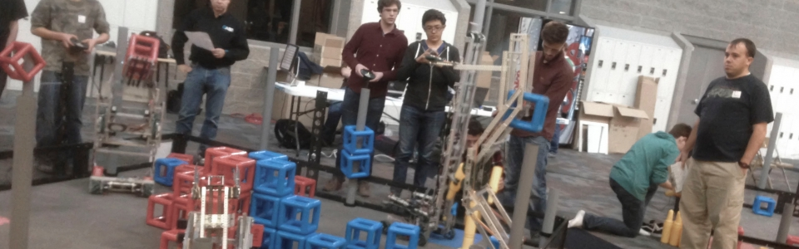

(Banner Image, sorry for low resolution)

**VEX Robotics**

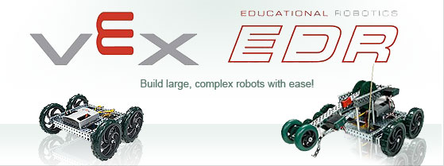

**What is VEX Robotics?**

VEX Robotics is an extra-curricular, educational program that offers students an exciting platform for learning about areas with career opportunities spanning science, technology, engineering and math (STEM). Besides science and engineering principles, VEX promotes teamwork, leadership and problem solving in an environment where students can meet a variety of other people. VEX provides a variety of customizable diffuculty levels that can be adapted to meet the level of the student's abilities. VEX is available as educational sets for the classroom as well as professional competition sets used in the international VEX Robotics competition.

**Education**

VEX Education is dedicated to providing engaging and fun student experiences that enable individuals to reach their full potential while they develop the knowledge and skills vital to success in the 21st Century. Given today’s global challenges compared to the rest of recorded history, there has never been an age with a greater need for new scientists, engineers and problem solving leaders. Recent breakthroughs in chemistry, medicine and physics have revealed a new set of challenges and created even greater opportunity for problem solving through technology. This underscores a dramatic challenge: there are not enough students choosing related paths to meet that global demand.

Recognizing this dilemma, scores of governments and organizations are turning toward programs that integrate science, technology, engineering and mathematics (STEM) as a means to meaningfully engage and develop the next generation. VEX Education exists to help schools focus on practical, affordable and accessible ways of delivering dynamic hands-on STEM educational experiences to as many students as possible. Mixing the excitement and motivation associated with competition and real-world applications of mathematics and science concepts through the use of the engineering design process, we focus on addressing current educational and societal needs on many levels.

The study of robotics, by its very nature, captures all four legs of STEM very well while a competitive environment increases motivation and desire to succeed, thus creating classroom environments where both knowledge and skill development can flourish without having to compromise one for the other. Whether it’s our classroom competition products, our classroom lab packages, one or more of our curriculum options, selections from our free education resources or some combination of them all, VEX Education continues to be a world-leader in classroom robotics applications and stands poised to help schools meet the growing global demands of the 21st Century.

**Competition:**

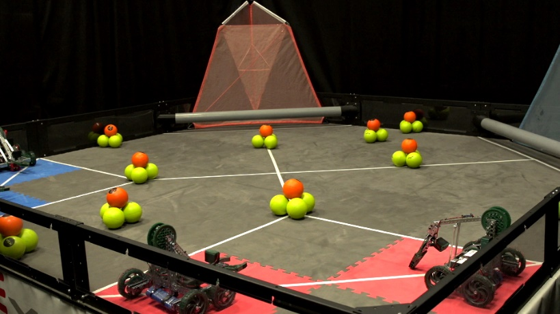

VEX Robotics Competition Nothing But Net is played on a 12’x12’ square field configured as seen above. Two alliances – one “red” and one “blue” – composed of two teams each, compete in matches consisting of a fifteen second autonomous period followed by one minute and forty-five seconds of driver-controlled play.

The object of the game is to attain a higher score than the opposing Alliance by Scoring your Balls and Bonus Balls in your Low and High Goals, and by Elevating Robots in your Climbing Zone.

**Scoring:**

|  |  |
| --- | --- |
| Each Ball scored in a Low Goal | 1 point |
| Each Bonus Ball Scored in a Low Goal | 2 points |
| Each Ball Scored in a High Goal | 5 points |
| Each Bonus Ball Scored in a High Goal | 10 points |
| Each Robot that is Low Elevated | 25 points |
| Each Robot that is High Elevated | 50 points |
| Alliance with the most points at the end of Autonomous | 10 points |

**The Details:**

There are ninety-four (94) Balls and ten (10) Bonus Balls, available as Scoring Objects. Some Scoring Objects begin in designated locations on the field, while others are available to be entered into the field during to the Match.

Each Robot (smaller than 18”x18”x18”) begins a match on one of their Alliance Starting Tiles. Each Alliance has one High Goal and one Low Goal to Score into. Alliances also earn points for Low and High Elevating one of their Robots upon the other. A bonus is awarded to the Alliance that has the most total points at the end of the Autonomous Period.

**Skyline VEX**

Skyline High School's VEX Robotics Team is now two year old. This year, Skyline High School has just begun offering a new Technology class called “Exploring Computer Technology II” which will focus on the process of design and building of VEX robotics.

For the competition Skyline built one robot dubbed "Brutus" drawing from past success of other robots. “The old Brutus was a true champion.” Skyline is hoping to use the tradition of Brutus to their advantage and make it to the State competition this year as well as win the competition at the Utah State TSA conference.

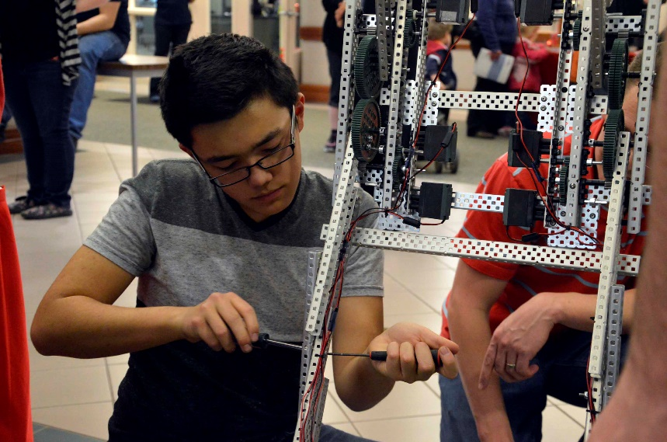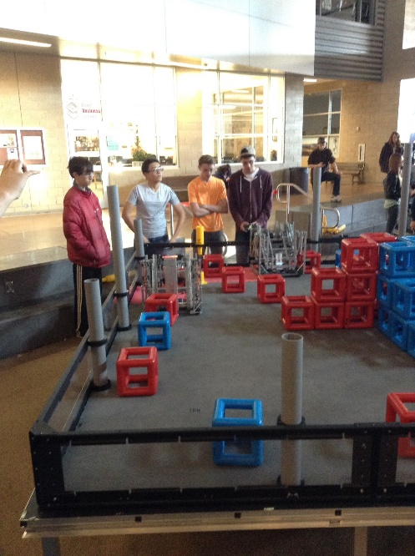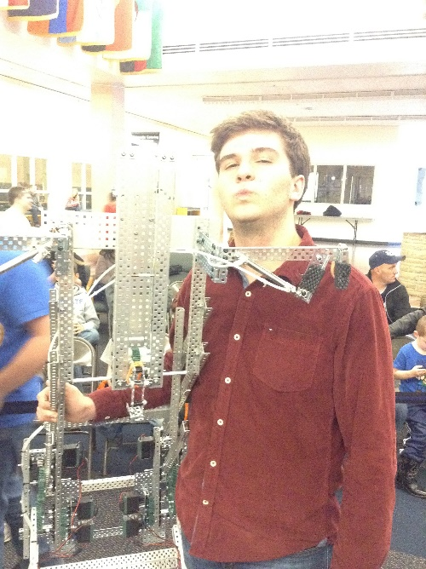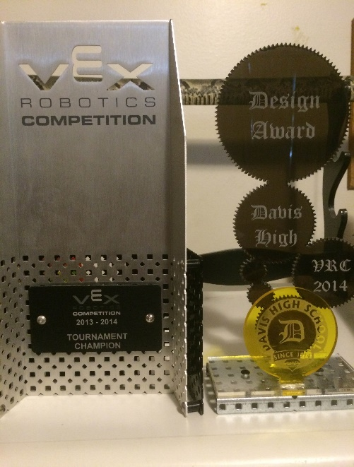The VEX team now provides educational lessons on how to build VEX robots as well as how to program them using the RobotC programming language. These lessons are available to all students in both TSA or just in general who are interested in STEM and robotics.

